DFD DIAGRAMS:

Context Level Dfd

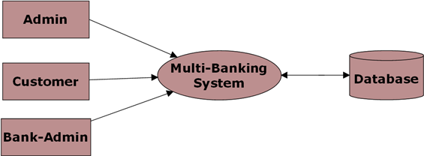

Level 0 DFD for Admin:

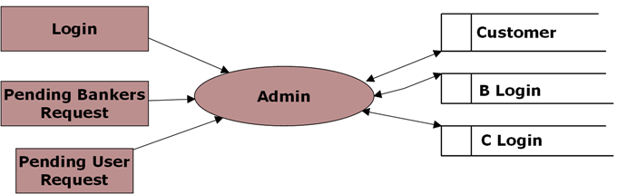

Level 0 DFD for Customer:

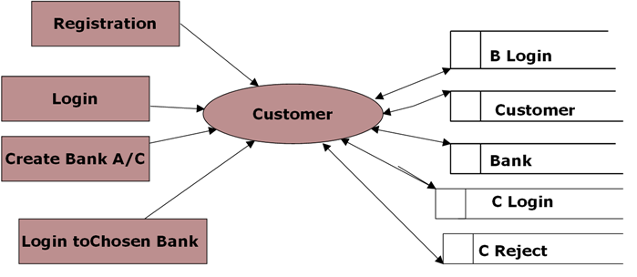

Level 0 DFD for Bank Admin:

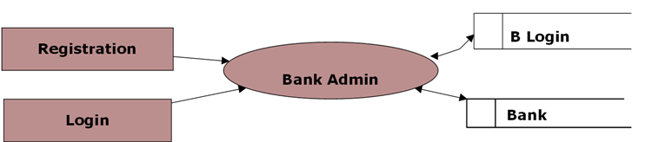

Level 1 DFD for Chosen Bank:

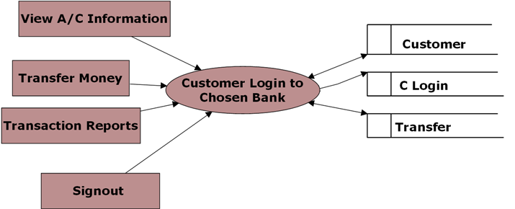

Level 1 DFD for Banker Login:

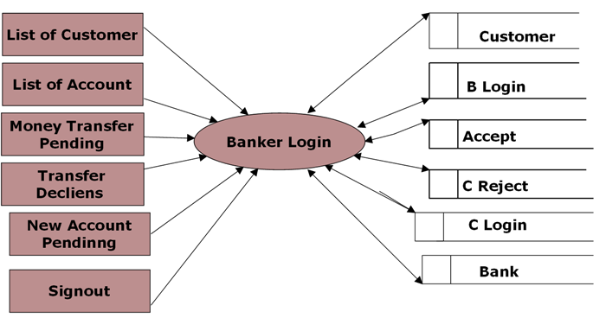

Level 2 for Money Transfer:

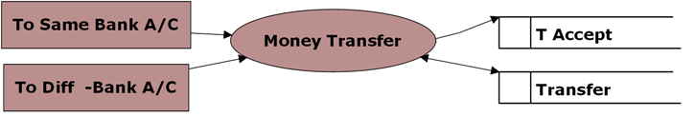

Level 2 DFD for Transaction Reports:

